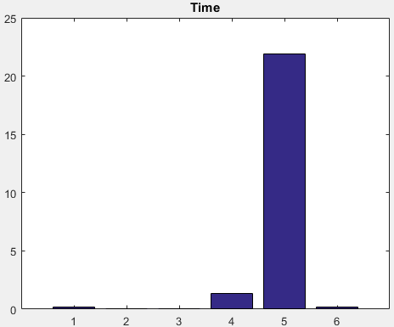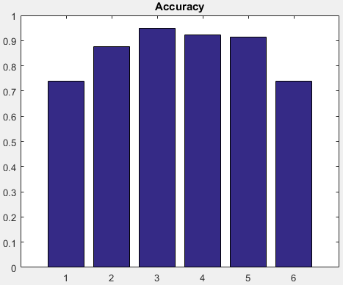Classification Technique Comparison

1. 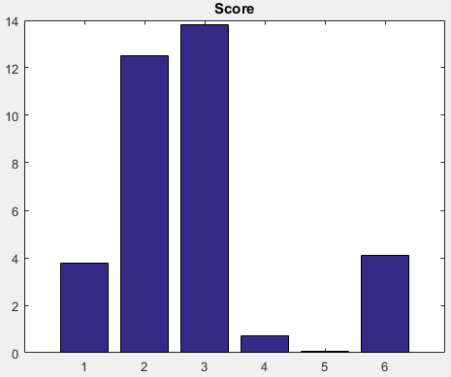Gaussian SVM
2. Linear SVM
3. RBF SVM
4. Polynomial SVM
5. LDA
6. KNN